***CENTRAL FLORIDA PARALEGAL ASSOCIATION, INC.  
CP Examination “SCHOLARSHIP” APPLICATION***

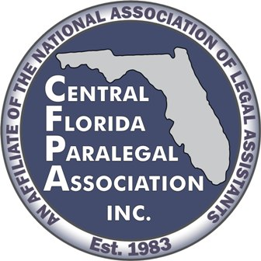

**APPLICANT MUST BE A CFPA MEMBER**

The criteria for determining the recipient of the Certified Paralegal Examination “scholarship” shall be established by the Board of Directors and the Scholarship Committee of the Central Florida Paralegal Association, Inc. Items to be considered are past CFPA involvement/leadership, interest in future CFPA involvement/leadership, paralegal career goals, essay composition/grammar, community involvement and eligibility for CP. Each of the categories shall be weighed at the discretion of the Scholarship Committee. The CP scholarship award will be for a current CFPA member only. Applicant does NOT need to be a NALA member to qualify for the scholarship. The applicant DOES need to be able to fulfill NALA’s requirements for eligibility for taking the CP examination. Requirements for the CP examination are listed at: https://www.nala.org/application-qualifications-fees.

The CP scholarship award will consist of the following: $275 paid directly to NALA by CFPA. This amount includes one attempt for the Knowledge Exam and one attempt for the Skills exam. This does not include any testing center fees.

**The winner will be announced on or before November 15, 2023.**

Please complete the information below.

Name: Phone Number:

(Please Type or Print)

Address:

E-Mail Address:

**Please include with this application the following items:**

1. A list or summary of your job history, activities, volunteer work, community service, CFPA involvement, NALA involvement, leadership positions, and any special awards or recognition you have received; and
2. In five hundred words or less, tell us how receiving this scholarship will make a difference in your paralegal career and how it will make a difference in your CFPA membership.

(All materials become the property of CFPA and will not be returned.)

**PLEASE RETURN THE COMPLETED APPLICATION AND REQUESTED ITEMS VIA EMAIL TO** [**scholarship@cfpanc.org**](mailto:scholarship@cfpanc.org)**.**

**DEADLINE: November 3, 2023**Applications postmarked or emailed after this date will not be considered.